**NIPWG xx-xx**

## Paper for Consideration by NIPWG

## Synergies between S-124 and NtM exchange format

|  |  |
| --- | --- |
| ***Submitted by:*** | S-124CG Chair |
| ***Executive Summary:*** | Proposal to consider the work of S-124CG for use in XML based Notice to Mariners information exchange. |
| ***Related Documents:*** | S-52, S-53, S-100 |
| ***Related Projects:*** | S-124 |

## Introduction / Background

S-124 is under development to be an S-100 based GML product, for exchange of Navigational Warning (NW) information for ECDIS/ECS, in alignment with S-53. Support for T & P Notice to Mariner (NtM) information was included in S-124 following requests of S-124CG membership, especially following the development of the Danish NiORD system, and similar systems using the same source code as a starting point. This was done because it was noted that there is a close relationship between NW and NtM, especially the temporary and preliminary types. Since this development, WWNWS-SC10 has determined that S-124 should only be for NW information. This decision was primarily based on the fact that NW has a time critical component for their issuance, while NtMs are typically updates to existing Maritime Safety Information (publications/charts).

## Analysis/Discussion

S-4 B-630 specifies how NtM should be applied to paper chart and ENC. However, NtM information that does not apply to charts, but which is navigationally significant, including some T and P information, still needs a venue to reach the mariner in the digital era. S-124 covers Navigational Warnings, but with this existing gap between NW and ENC/NPUB for some of the T/P and NtM, some information may not make it to the navigation system display, unless added as Mariners’ Objects via the navigation system interface. This process can be time consuming and human errors may be introduced. Reasons for this can be that the duration of the information may be too short for the production process limits or there may be no suitable encoding class (e.g. out of scope of products). Appendix A illustrates how NW information may transition to NtM information.

ECDIS OEMs have expressed an interest in a format for NtM information to cover the gap between NW and ENC/NPUB. It is envisioned that such a product will also increase consistency of information for the end user, and save time that the users otherwise would have needed to create Mariners’ Objects.

As approved by HSSC10 in action HSSC10/41, NIPWG is looking to develop a harmonized XML exchange format for NtM information between countries. It is the opinion of the S-124CG Chair that if structured accordingly, the XML exchange format can serve multiple purposes. It is envisioned that the primary purpose of being an exchange format for NtM information between agencies can be extended to mariners as an input to navigation systems and other systems that display navigation information such as ENC and NPUBs.

It should be noted that GML is XML based, and is a flexible format that could be used to serve both needs, as well as be convertible through style sheets to HTML and PDF publishing. GML is profiled by S-100 as an encoding format, which means that should the XML exchange format for NtM information utilize S-100 GML, an S-100 product specification could be built around it permitting multiple usages of the same data. Such a product specification may be able to align well with the S-124 Product Specification and thus strengthen the symbiosis that often exists between NW and NtM information.

S-124 information is often published by the same organisations that also generate NtM information. It is therefore operationally interesting to ensure that S-124 information can easily be converted into NtM information. Canadian Hydrographic Service (CHS) and Canadian Coast Guard (CCG) are testing the S-124 data model with NtM support and preliminary findings show that it can support Canadian NtMs for various usages. The data model (See Appendix B) and GML application schemas utilized in these tests is available to NIPWG should it be of interest. Figure A below shows a simple map of NtM datasets generated in the ongoing tests.

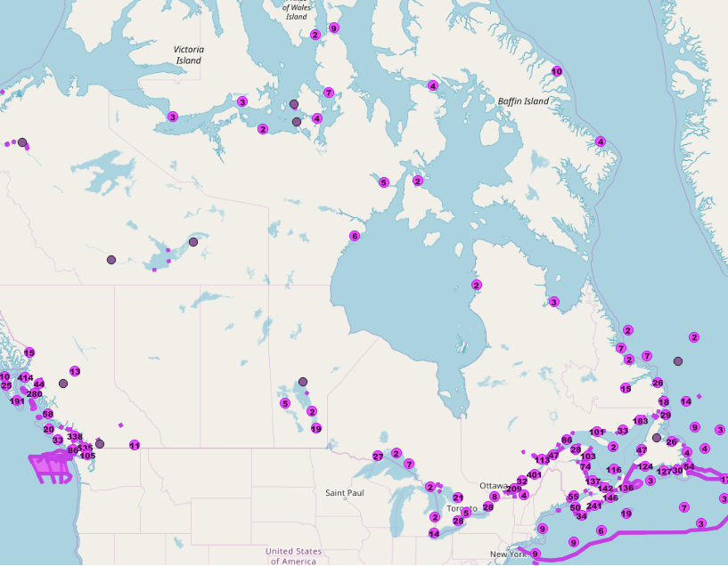

Figure A - Sample of map with CHS NtM using the S-124 data model

## Conclusions

The work of S-124CG seems to offer a suitable starting point for NIPWG’s work on an XML format for NtM information exchange, and can offer a close relationship with S-124 NW. This could simplify the development and yield benefits in the data management of navigationally significant information through the first stages of its life-cycle.

## Action Required of NIPWG

The NIPWG is invited to:

a. consider the work of S-124CG as an input to its work on NtM exchange format.

Appendix A – High level NW to NtM information flow



Figure B - NW Information Flow

Appendix B – Draft S-124 data model including NtM

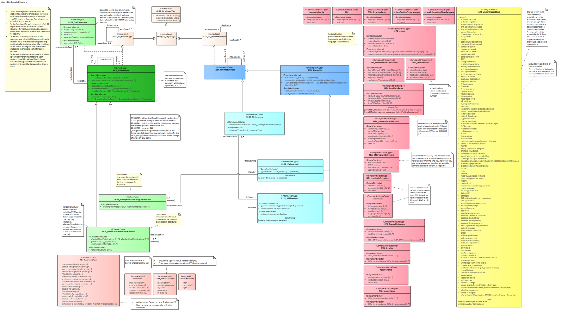

Figure C - Draft Full S-124 data model



Figure D - NtM component of draft S-124